# [**‘Law & Order: Organized Crime’ Names Fifth Showrunner**](https://www.hollywoodreporter.com/tv/tv-news/law-order-organized-crime-names-fifth-showrunner-1235623302/)

John Shiban has joined the Wolf Entertainment fold after work on ‘Ozark’ and ‘The X-Files.’

**BY** [**LESLEY GOLDBERG**](https://www.hollywoodreporter.com/author/lesley-goldberg/)

Plus Icon

OCTOBER 19, 2023 4:00PM

* [Share this article on Facebook](https://www.facebook.com/sharer.php?u=https://www.hollywoodreporter.com/tv/tv-news/law-order-organized-crime-names-fifth-showrunner-1235623302/&title=%E2%80%98Law%20&%20Order:%20Organized%20Crime%E2%80%99%20Names%20Fifth%20Showrunner&sdk=joey&display=popup&ref=plugin&src=share_button&app_id=1153511048447777)
* [Share this article on Twitter](https://twitter.com/intent/tweet?url=https://www.hollywoodreporter.com/tv/tv-news/law-order-organized-crime-names-fifth-showrunner-1235623302/&text=%E2%80%98Law%20%26%20Order%3A%20Organized%20Crime%E2%80%99%20Names%20Fifth%20Showrunner&via=thr)
* [Share this article on Flipboard](https://share.flipboard.com/bookmarklet/popout?v=2&url=https://www.hollywoodreporter.com/tv/tv-news/law-order-organized-crime-names-fifth-showrunner-1235623302/&title=%E2%80%98Law%20&%20Order:%20Organized%20Crime%E2%80%99%20Names%20Fifth%20Showrunner)
* [Share this article on Email](mailto:?subject=thr%20:%20%E2%80%98Law%20&%20Order:%20Organized%20Crime%E2%80%99%20Names%20Fifth%20Showrunner&body=https://www.hollywoodreporter.com/tv/tv-news/law-order-organized-crime-names-fifth-showrunner-1235623302/%20-%20%E2%80%98Law%20&%20Order:%20Organized%20Crime%E2%80%99%20Names%20Fifth%20Showrunner)
* [Show additional share options](https://www.hollywoodreporter.com/tv/tv-news/law-order-organized-crime-names-fifth-showrunner-1235623302/#)

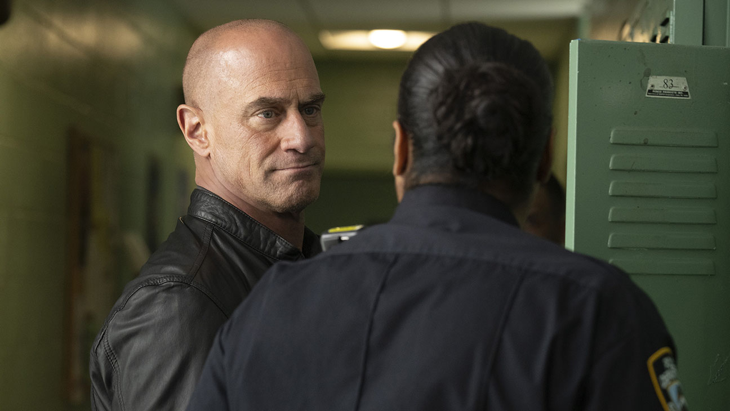

Chris Meloni as Det. Elliot Stabler in LAW & ORDER: ORGANIZED CRIME VIRGINIA SHERWOOD/NBC/NBCU PHOTO BANK VIA GETTY IMAGES

[Logo text](https://www.hollywoodreporter.com/e/live-feed/)

*Law & Order: Organized Crime* has named its fifth showrunner.

Veteran showrunner John Shiban (*Ozark, The X-Files*) has been tapped to take over the helm of the fourth season of the Dick Wolf procedural. Shiban replaces David Graziano, with the *SVU* grad taking over the remainder of season three for Sean Jablonski.

Jablonski, who departed the Chris Meloni-led spinoff after creative differences, replaced Bryan Goluboff. Goluboff stepped in for Barry O’Brien, who was tapped as interim showrunner after original showrunner Ilene Chaiken departed.